|  |  |  |  |
| --- | --- | --- | --- |
| Variable | Valor calculado | Valor medido | Error porcentual |
| VR1 (V) | 2.05 | 2.05 | 0.01 % |
| IR1 (mA) | 2.05 | 2.05 | 0.01% |
| VR2 (V) | 4.24 | 4.25 | 0.01% |
| IR2 (mA) | 1.09 | 0.965 | 11.46% |
| VR3 (V) | 2.12 | 2.12 | 0.01% |
| IR3 (mA) | 0.964 | 0.965 | 0.01% |
| VR4 (V) | 2.12 | 2.12 | 0.01% |
| IR4 (mA) | 0.964 | 0.965 | 0.10% |
| VR5 (V) | 3.69 | 3.70 | 0.27% |
| IR5 (mA) | 2.05 | 2.05 | 0.01% |

Tabla 1.1. Resultados obtenidos de voltaje y corriente, en cada elemento del circuito.

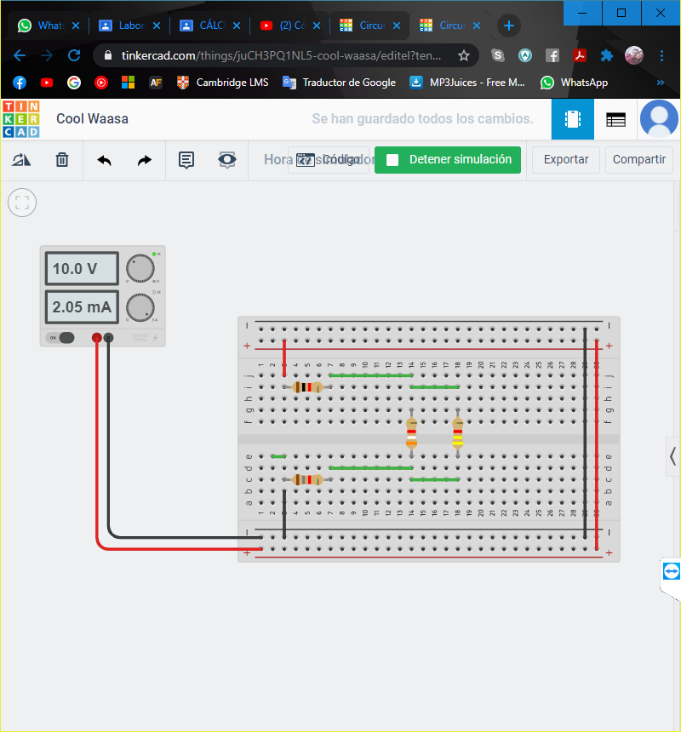**CÁLCULOS**

$$R_{eq1}=R_{3}+R_{4}$$

$$R_{eq1}=2200+2200$$

$$R_{eq1}=4400 Ω$$

$$R_{eq1}=4.4 mΩ$$

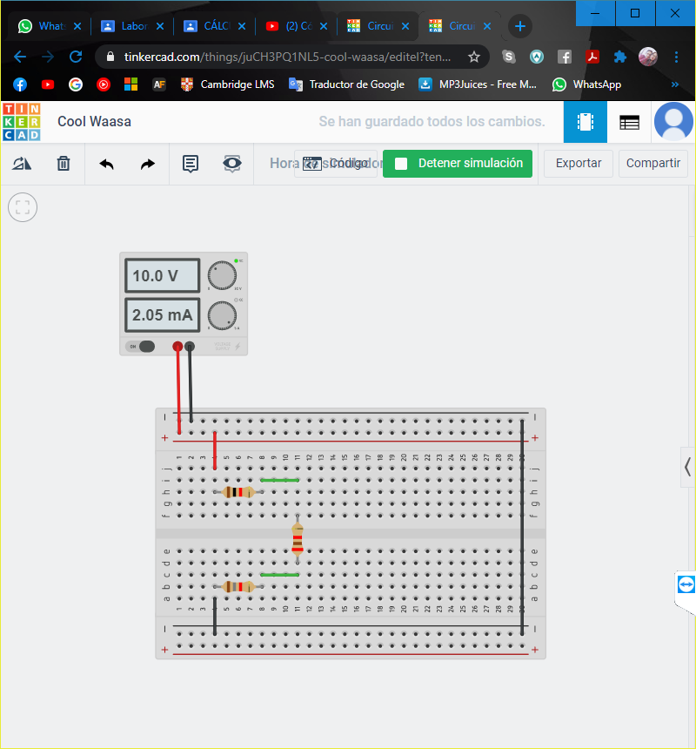

$$\frac{1}{R_{eq2}}=\frac{1}{R_{2}}+\frac{1}{R_{eq1}}$$

$$\frac{1}{R_{eq2}}=\frac{1}{3900}+\frac{1}{4400}$$

$$\frac{1}{R_{eq2}}=\frac{83}{171600}$$

$$R_{eq2}=\frac{171600}{83}$$

$$R_{eq2}=2067.47 Ω$$

$$R_{eq2}=2.067 mΩ$$

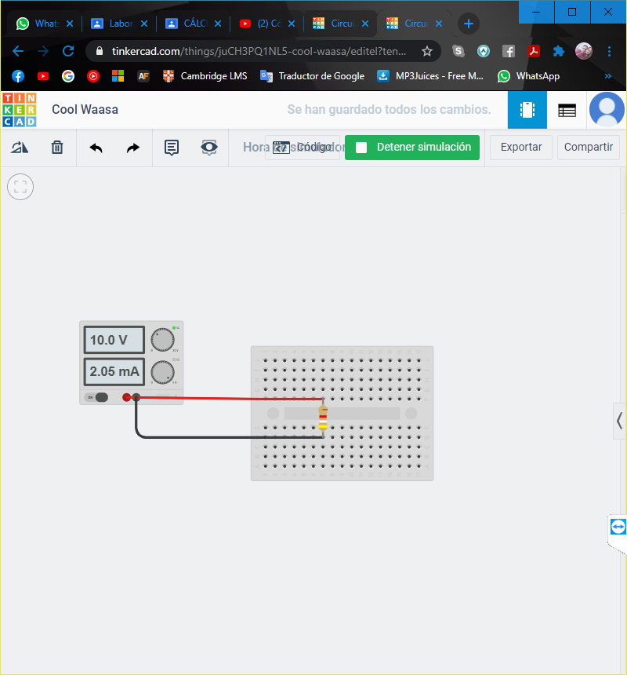

$$R_{eq3}= R_{1}+ R_{eq2}+ R_{5}$$

$$R_{eq3}= 1000+ 2.067+ 1800$$

$$R_{eq3}= 4867.47 Ω$$

$$R_{eq3}= 4.867 mΩ$$

$$I_{T}=\frac{V}{R_{eq3}}$$

$$I_{T}=\frac{10}{4867.47}$$

$$I_{T}=2.05x10^{-3} A$$

$$I_{T}=2.05 mA$$

**Para resistencia 1**

$$V_{R1}=I_{T} x R_{1}$$

$$V_{R1}=2.05x10^{-3} x 1000$$

$$V_{R1}=2.05 V$$

$$I_{R1}=\frac{V_{R1}}{R_{1}}$$

$$I_{R1}=\frac{2.05}{1000}$$

$$I_{R1}=2.05x10^{-3} A$$

$$I_{R1}=2.05 mA$$

**Para resistencia 2**

$$V_{Req2}=R_{eq2} x I_{T}$$

$$V_{Req2}=2067.47 x 2.05x10^{-3}$$

$$V_{Req2}=4.2383 V≈4.24 V$$

$$I_{Req2}=\frac{V_{Req2}}{R_{eq2}}$$

$$I_{Req2}=\frac{4.24}{2067.47}$$

$$I_{Req2}=2.05x10^{-3} A$$

$$I_{Req2}=2.05 mA$$

$$V_{R2}=4.24 V$$

$$I_{R2}=\frac{V_{R2}}{R_{2}}$$

$$I_{2}=\frac{4.24}{3900}$$

$$I_{R2}=1.0871x10^{-3} A≈1.09 mA$$

**Para resistencia 3**

$$I_{Req1}=\frac{V_{Req1}}{R_{eq1}}$$

$$I_{Req1}=\frac{4.24}{4400}$$

$$I_{Req1}=9.64x10^{-4} A=964x{10}^{-6} A$$

$$I_{Req1}=964 µA$$

$$I_{Req1}=0.964 mA$$

$$I_{R3}=0.964 mA$$

$$V_{R3}= I_{R3} x R_{3}$$

$$V_{R3}=0.964x{10}^{-3} x 2200$$

$$V_{R3}=2.12 V$$

**Para resistencia 4**

$$I_{R3}=I_{R4}=0.964 mA$$

$$V_{R3}= I_{R4} x R_{4}$$

$$V_{R4}=0.964x{10}^{-3} x 2200$$

$$V_{R4}=2.12 V$$

**Para resistencia 5**

$$V_{R5}= I_{T} x R_{5}$$

$$V_{R3}= 2.05x{10}^{-3} x 1800$$

$$V_{R3}= 3.69 V$$

$$I_{R5}=\frac{V_{R5}}{R_{5}}$$

$$I_{R5}=\frac{3.69}{1800}$$

$$I_{R5}=2.05x{10}^{-3} A$$

$$I_{R5}=2.05 mA$$

Tabla 1.2 Verificación de la tabla LVK

|  |  |  |  |  |  |  |  |
| --- | --- | --- | --- | --- | --- | --- | --- |
| VOLTAJE | TRAYECTORIA 1 | | TRAYECTORIA 2 | | TRAYECTORIA 3 | |  |
| **Calculado** | **Medido** | **Calculado** | **Medido** | **Calculado** | **Medido** | **Error porcentual** |
| VT (V) | 10 | 10 | 0 | 0 | 0 | 0 | - |
| VR1 (V) | 2.05 | 2.05 | 0 | 0 | 2.05 | 2.05 | 0.01% |
| VR2 (V) | 4.25 | 4.25 | 4.25 | 4.25 | 0 | 0 | 0.01% |
| VR3 (V) | 0 | 0 | 2.12 | 2.12 | 2.12 | 2.12 | 0,01% |
| VR4 (V) | 0 | 0 | 2.12 | 2.12 | 2.12 | 2.12 | 0.01% |
| VR5 (V) | 3.69 | 3.70 | 0 | 0 | 3.69 | 3.70 | 0.27% |
| ∑V | 19.99 | 20 | 8.49 | 8.49 | 9.98 | 9.98 | - |

**CÁLCULOS**

Trayectoria 1

$$6.7 I_{1}-3.9 I_{2}=10$$

Trayectoria 2

$$-3.9 I_{1}+8.3 I_{2}=0$$

$$-26.13 I_{1}+15.21 I_{2}=-39$$

$$26.13 I_{1}-55.61 I_{2}=0$$

$$-40.4 I_{2}=-39$$

$$I_{2}=0.964 mA$$

$$I_{1}=\frac{8.3I_{2}}{3.9}$$

$$I_{1}=\frac{8.3 x 0.96}{3.9}$$

$$I_{1}=\frac{8.3 x 0.96}{3.9}$$

$$I_{1}=2.043 mA$$

$$V=IR$$

$$V_{R1}=I_{1}R_{1}$$

$$V_{R1}=2.05x{10}^{-3} x 1000$$

$$V_{R1}=2.05 V$$

$$V_{R5}=I_{5}R_{5}$$

$$V_{R5}=2.05x{10}^{-3} x 1800$$

$$V_{R5}=3.69 V$$

$$V_{R3}=I_{3}R_{3}$$

$$V_{R3}=0.964x{10}^{-3} x 2200$$

$$V_{R3}=2.12 V$$

$$V_{R3}=V_{R4}=2.12 V$$

$$V_{R2}={(I}_{1}-I_{2}) x 3.9$$

$$V_{R2}=1.09 x 3.9$$

$$V_{R2}=4.25 V$$

Tabla 1.3 Verificación de la LCK

|  |  |  |  |  |  |  |
| --- | --- | --- | --- | --- | --- | --- |
| AMPERAJE | NODO 1 | |  | NODO 2 | |  |
| **Calculado** | **Medido** | **Error porcentual** | **Calculado** | **Medido** | **Error porcentual** |
| IT (V) | 2.05 | 2.05 | 0.01% | 0.964 | 0.965 | 0.10% |
| IR1 (V) | 2.05 | 2.05 | 0.01% | 0 | 0 | - |
| IR2 (V) | 1.09 | 0.965 | 11.46% | 1.09 | 0.965 | 11.46% |
| IR3 (V) | 0 | 0 | - | 0.964 | 0.965 | 0.10% |
| IR4 (V) | 0 | 0 | - | 0.964 | 0.965 | 0.10% |
| IR5 (V) | 2.05 | 2.05 | 0.01% | 0 | 0 | - |
| ∑I | 7.24 | 7.115 | - | 3.98 | 3.86 | - |

$$I=\frac{V}{R}$$

$$I_{R1}=\frac{2.05}{1000}=2.05 mA$$

$$I_{R2}=\frac{4.25}{3900}=1.09 mA$$

$$I_{R3}=\frac{2.12}{2200}=0.964 mA$$

$$I_{R3}=I_{R4}=0.964 mA$$

$$I_{R5}=\frac{3.69}{1800}=2.05 mA$$

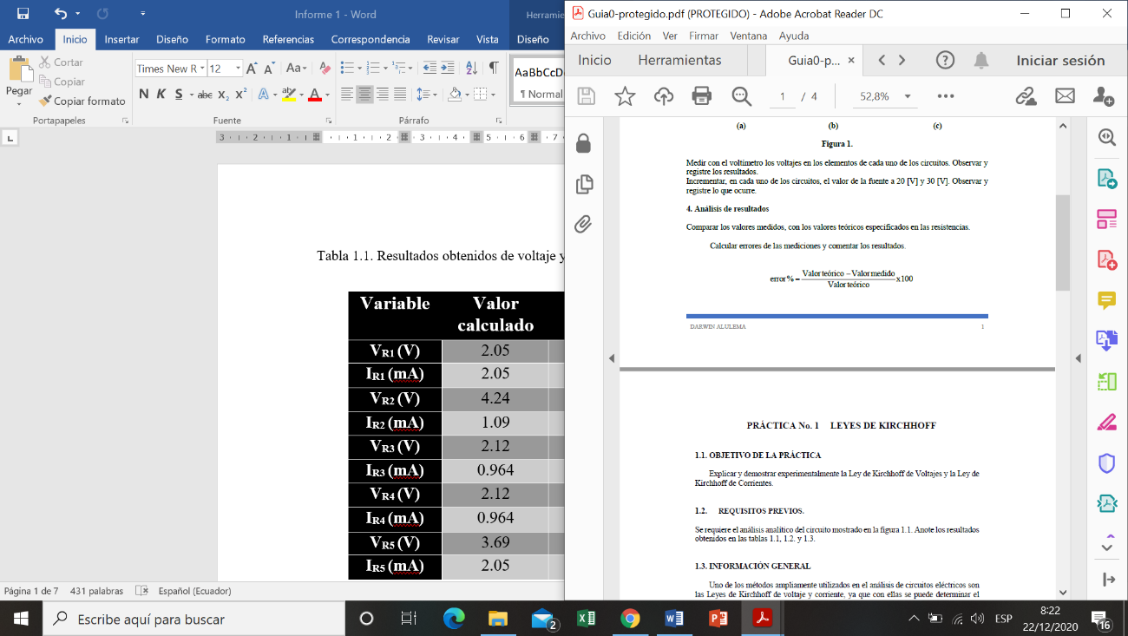Formulas a considerar: